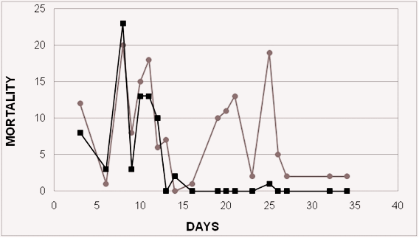
Figure 1 - Graphical representation of Tilapia mortality of Supreme strain in two treatments with water temperature for 34 days. The cinder line represents the treatment at 25° C and the black line represents the treatment at 35° C.

